SWIGGY SALES ANALYSIS
MS SQL SERVER QUERIES

Check for all data in swiggy_data table
SELECT * FROM swiggy_data
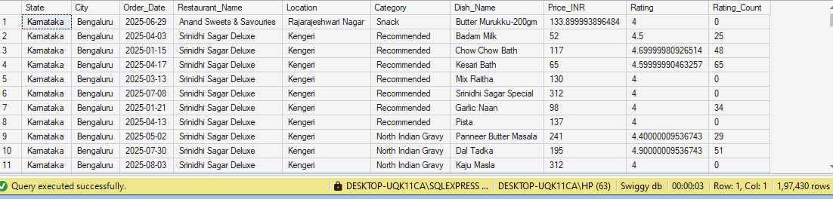

Check for all null Values in each column
SELECT
SUM(CASE WHEN State IS NULL THEN 1 ELSE 0 END) AS null_state,
SUM(CASE WHEN City IS NULL THEN 1 ELSE 0 END) AS null_city,
SUM(CASE WHEN Order_Date IS NULL THEN 1 ELSE 0 END) AS null_order_date,
SUM(CASE WHEN Restaurant_Name IS NULL THEN 1 ELSE 0 END) AS null_restaurant_name,
SUM(CASE WHEN Location IS NULL THEN 1 ELSE 0 END) AS null_location,
SUM(CASE WHEN Category IS NULL THEN 1 ELSE 0 END) AS null_category,
SUM(CASE WHEN Dish_Name IS NULL THEN 1 ELSE 0 END) AS null_dish_name,
SUM(CASE WHEN Price_INR IS NULL THEN 1 ELSE 0 END) AS null_price_inr,
SUM(CASE WHEN Rating IS NULL THEN 1 ELSE 0 END) AS null_rating,
SUM(CASE WHEN Rating_Count IS NULL THEN 1 ELSE 0 END) null_rating_count
FROM swiggy_data

--Blank & Empty Strings
SELECT * FROM swiggy_data
WHERE State= '' OR City= '' OR Order_Date= '' OR Restaurant_Name= '' OR Location= '' OR Category= '' OR Dish_Name='';
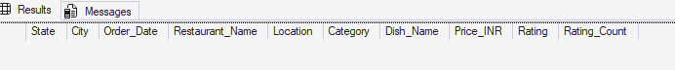
--Duplicate Detection
SELECT State, City, Order_Date, Restaurant_Name, Location, Category, Dish_Name,
Price_INR, Rating, Rating_Count, COUNT(*) AS CNT FROM swiggy_data
GROUP BY State, City, Order_Date, Restaurant_Name, Location, Category, Dish_Name,
Price_INR, Rating, Rating_Count
HAVING COUNT(*)> 1;
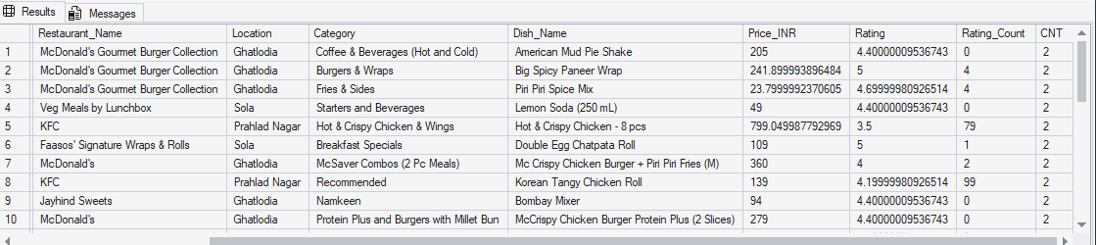

--Delete Duplication
WITH CTE AS(
SELECT *, ROW_NUMBER() OVER( PARTITION BY State, City, Order_Date, Restaurant_Name, Location,
Category, Dish_Name, Price_INR, Rating, Rating_Count ORDER BY (SELECT NULL)) AS rn
FROM swiggy_data
)
DELETE FROM CTE WHERE rn > 1;
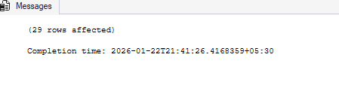

-- Creating Schema
--Dimension Tables
--Date Table
CREATE TABLE dim_date(
date_id INT IDENTITY(1,1) PRIMARY KEY,
Full_Date DATE,
Year INT,
Month INT,
Day INT,
Week INT,
Quater INT,
Month_Name VARCHAR(20)
)
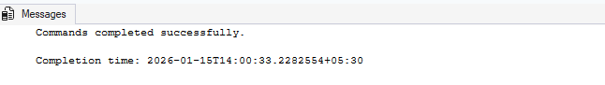
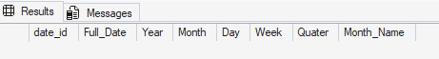

--Location Table
CREATE TABLE dim_location(
location_id INT IDENTITY(1,1) PRIMARY KEY,
State VARCHAR(100),
City VARCHAR(100),
Location VARCHAR(200)
);

--Restaurant Table
CREATE TABLE dim_restaurant(
restaurant_id INT IDENTITY(1,1) PRIMARY KEY,
Restaurant_Name VARCHAR(200)
);

--Category Table
CREATE TABLE dim_category(
category_id INT IDENTITY(1,1) PRIMARY KEY,
category VARCHAR(200)
);

-- Dish Table
CREATE TABLE dim_dish(
dish_id INT IDENTITY(1,1) PRIMARY KEY,
Dish_Name VARCHAR(200)
)

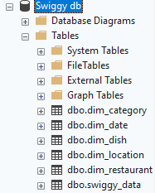

--Fact Table
CREATE TABLE fact_swiggy_orders(
order_id INT IDENTITY(1,1) PRIMARY KEY,
date_id INT,
Price_INR decimal(10,2),
Rating decimal(4,2),
Rating_Count INT,

location_id INT,
restaurant_id INT,
category_id INT,
dish_id INT,

FOREIGN KEY (date_id) REFERENCES dim_date(date_id),
FOREIGN KEY (location_id) REFERENCES dim_location(location_id),
FOREIGN KEY (restaurant_id) REFERENCES dim_restaurant(restaurant_id),
FOREIGN KEY (category_id) REFERENCES dim_category(category_id),
FOREIGN KEY (dish_id) REFERENCES dim_dish(dish_id)
);

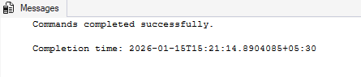
--Insert data into tables
-- dim_date
INSERT INTO dim_date (Full_Date, Year, Month, Month_Name, Quater, Day, Week)
SELECT DISTINCT
Order_Date,
YEAR(Order_Date),
MONTH(Order_Date),
DATENAME(MONTH,Order_Date),
DATEPART(QUARTER, Order_Date),
DAY(Order_Date),
DATEPART(WEEK, Order_Date)
FROM swiggy_data
WHERE Order_Date IS NOT NULL

SELECT * FROM dim_date
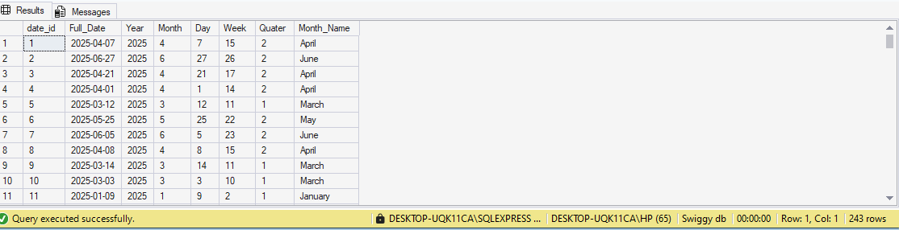

-- dim_location
INSERT INTO dim_location(State, City, Location)
SELECT DISTINCT
State,
City,
Location
FROM swiggy_data
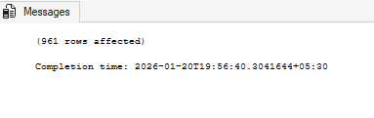
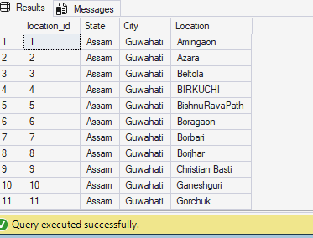

--dim_restaurant
INSERT INTO dim_restaurant (Restaurant_Name)
SELECT DISTINCT
Restaurant_Name
FROM swiggy_data
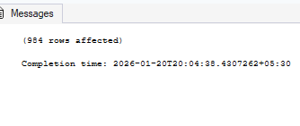
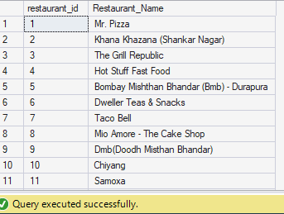

--dim_category
INSERT INTO dim_category(category)
SELECT DISTINCT
Category
FROM swiggy_data
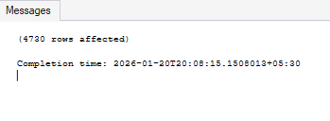
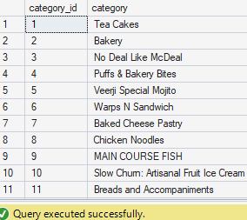

--dim_dish
INSERT INTO dim_dish(Dish_Name)
SELECT DISTINCT
Dish_Name
FROM swiggy_data
